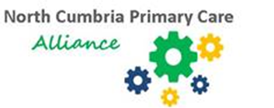**North Cumbria Primary Care Alliance**

**Management Accountant**

Based at: West or North Cumbria

Hours: 37.5 per week

Salary: £40,800 -£50,100

A new role has arisen for a highly proficient Management Accountant to join North Cumbria Primary Care. This is a broad role, reporting to the Managing Director and Director of Finance, working across primary care services in North Cumbria.

North Cumbria Primary Care Ltd (NCPC) is an innovative not for profit social enterprise, established to create a network of great practices that sustains and supports the development of general practice across the local area. We enable our member general practices to continue to operate as local family practices with the benefit of a large and robust infrastructure to provide support.

We want our practices to become wellbeing practices, actively closing the gaps around mortality and morbidity. The ethos of the company is one of collaboration, learning and continuous improvement.

This role is key to the success of the organisation. We need someone to further develop and strengthen our financial systems and processes to ensure robust financial management and control.

For an informal discussion or further information regarding the post please contact:

[Joanne.percival2@cumbria.nhs.uk](mailto:Joanne.percival2@cumbria.nhs.uk)

07919 171982